**CSE 212 – Programming with Data Structures**

**W01 Prove – Response Document**

|  |  |
| --- | --- |
| **Name:** | Enmanuel De los Santos Cruz |
| **Date:** | 09/24/2022 |
| **Teacher:** | Zachariah Alvey |

*It is a violation of BYU-Idaho Honor Code to post or share this document with others or to post it online. Storage into a personal and private repository (e.g. private GitHub repository, unshared Google Drive folder) is acceptable.*

**Question 1: For the rotate right problem, provide a description of how you solved the problem.**

* The code is iterating through a list of numbers, and then appending the result to another list.
* The code is doing this by using range() to create a new list with len(list) - num items in it.
* Then, for each item in that new list, the code is appending the current item into the result list.
* Finally, when all items have been processed through this loop, they are being added back into their original position in the original list.
* The main function of this program is rotate_list_right().
* This function takes two parameters: 1) A reference to an existing Python List object called "list" 2) An integer value which specifies how many elements should be removed from "list".
* The code is used to rotate a list of integers.
* The first line creates an empty list, then the second line iterates through the length of the list and adds each item in the range from 0 to len(list) - num.
* The third line iterates through the length of the list and appends each item in the range from len(list) - num to 0.

**Question 2: For the rotate right problem, draw a picture of how you solved the problem.**

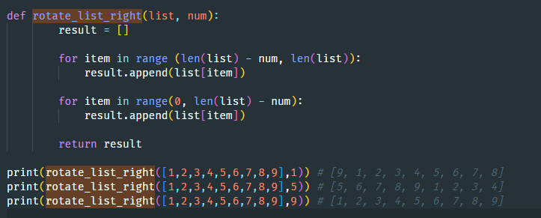

Remember: You need to submit the following code files in addition to this document:

* 01-prove_multiples_of.py
* 01-prove_rotate_list_right.py